 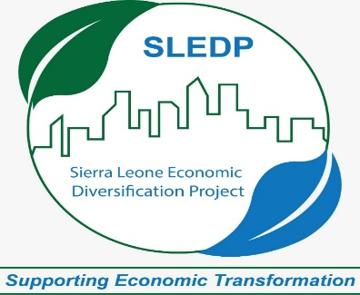 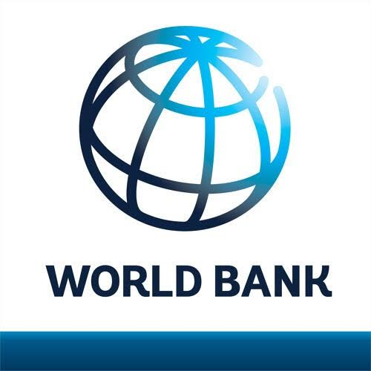

**SLEDP COVID -19 Implementation Manual**

1. **Background**

The COVID-19 pandemic, also known as the coronavirus pandemic, is an ongoing [global pandemic](https://en.wikipedia.org/wiki/Pandemic#COVID-19) of [coronavirus disease 2019](https://en.wikipedia.org/wiki/COVID-19) (COVID-19), which is caused by [severe acute respiratory syndrome coronavirus 2](https://en.wikipedia.org/wiki/Severe_acute_respiratory_syndrome_coronavirus_2) (SARS-CoV-2). The virus was first identified in December 2019 in [Wuhan](https://en.wikipedia.org/wiki/Wuhan), China. The [World Health Organization](https://en.wikipedia.org/wiki/World_Health_Organization) declared a [Public Health Emergency of International Concern](https://en.wikipedia.org/wiki/Public_Health_Emergency_of_International_Concern) regarding COVID-19 on 30 January, 2020, and later declared a [pandemic](https://en.wikipedia.org/wiki/Pandemic) on 11 March, 2020. As of 18 June, 2021, [more than 177 million cases](https://en.wikipedia.org/wiki/COVID-19_pandemic_cases) have been confirmed, with [more than 3.84 million confirmed deaths](https://en.wikipedia.org/wiki/COVID-19_pandemic_deaths) attributed to COVID-19, making it one of the [deadliest pandemics in history](https://en.wikipedia.org/wiki/List_of_epidemics#Major_epidemics_and_pandemics_by_death_toll).

The  COVID-19 pandemic in Sierra Leone  is part of the ongoing [worldwide pandemic](https://en.wikipedia.org/wiki/COVID-19_pandemic) of [coronavirus disease 2019](https://en.wikipedia.org/wiki/Coronavirus_disease_2019) (COVID-19) caused by [severe acute respiratory syndrome coronavirus 2](https://en.wikipedia.org/wiki/Severe_acute_respiratory_syndrome_coronavirus_2) (SARS-CoV-2). The virus was confirmed to have reached [Sierra Leone](https://en.wikipedia.org/wiki/Sierra_Leone) on 31 March 2020.

The Sierra Leone Economic Diversification Project will help strengthen the business enabling environment by promoting reforms to facilitate business entry and operation, facilitate strategic public investments to improve competitiveness and private investments, support SMEs and entrepreneurs, and build the capacity of public institutions and private sector operators.

Given the context in which the project will begin implementation, many of the initial project activities will directly support the government’s immediate efforts to address the economic impacts of the COVID-19 pandemic, in particular its impact on SMEs in hard-hit sectors, such as tourism. The project will contribute significantly to the COVID-19 recovery phase, with its focus on increasing diversification, strengthening resilience of economic sectors outside of mining and de-risking the country to make it more attractive to investments.

When faced with a threat, society do modify normal practices and behaviors to stay safe. This ‘species-preserving’ response has been seen all over the world throughout history, and was seen in Sierra Leone in response to the 2014-2015 Ebola outbreak. With appropriate mobilization and ongoing engagement, communities were able to rapidly acquire new knowledge, and take local action to reduce their risks. Communities are not the problem in an outbreak response, but takes active role in providing solutions, and they need to be engaged and empowered to lead the response on the frontline.

Effective Community Engagement (CE) activities will help communities to understand and take ownership of their situation, take local action and innovate to reduce their disease risks and mitigate the outbreak of secondary impact, and support response interventions, thereby creating a demand-driven response. Effective community engagement also creates a feedback loop between communities and service providers, as such, their needs are being met. ***This manual is in line with the Government of Sierra Leone and World Bank Covid - 19 Protocols and may change as per the prevailing circumstance.***

1. **Scope**

The purpose of this Standard Operating Procedures (SOPs) is to provide operational guidance on Community Engagement activities during the COVID - 19, and specifically, on the role of the Project Coordinating Unit (PCU) and Implementing Partners (IPs) conducting these activities on the ground. CE activities include both prevention and demand-generation activities to help them work effectively in the best interests of the community.

1. **Responsibilities**

Implementing Partners (IPs) will adhere to the provisions of this SOP when conducting CE activities. The Project Coordinating Unit will take responsibility for ensuring adherence and high-quality CE activities in practice. This responsibility will include ensuring that all involved are aware of, and oriented on this SOP.

1. **Safety & Security**

* PCU must avoid and pre-empt risks associated with the virus or violence; however, they must be prepared for different possibilities. IPs must take responsibility to provide adequate information, guidance, and support. PCU and IPs should be trained on core areas of safety and security including: entering and exiting communities; personal protection against disease transmission; minimizing risk of disease transmission in activities; negotiating with communities; safeguarding; and emergency protocols.
* PCU should ensure that IPs are properly introduced to key stakeholders; know the local by-laws; and receive a security update from local community members.
* PCU and IPs should always be equipped with soap and clean water or 60% alcohol-based hand sanitizer; a face mask and a functional handwashing machine.

1. **Minimizing Risk of Disease Transmission in CE Activities**

It is imperative that PCU and IPs make every effort to minimize the risk of disease transmission during CE activities. This means designing and planning activities in such a way that minimizes risk, and implementing, supervising, and monitoring activities in the safest way possible.

* When designing and planning activities, first consider whether they can be conducted remotely (e.g., via communication through phone, SMS, WhatsApp, email, Skype, Zoom, or Teams), if they can, arrange for this.

PCU / IPs always review restrictions that are in effect in the country / project area and how they would affect planned stakeholder engagement activities.

Early planning, i.e. identify activities under the project which require stakeholder engagement/meetings and plan for them well in advance.

PCU / IPs identifies channels for direct / one-on-one communication with each affected household, using a combination of methods (e.g., phone, SMS, survey, etc. as appropriate and feasible, with limited number of face-to-face meetings).

* Limit the number of people involved as much as possible.
* Limit the movement of people and the distances they cover as much as possible (e.g. deploy the minimum number of staff needed to implement the activity to a high quality).
* If any member (PCU / IPs) feel ill, it is requested the person / person (s) isolate themselves for days and visit the nearest medical center for further medical consultations.

1. **Protecting Children & Vulnerable Adults**

Abuse, sexual and gender-based violence, exploitation, and harassment can increase during outbreaks, especially during protracted outbreaks such as the COVID-19 pandemic. PCU have a critical role to play in preventing and responding to this issue.

• All IPs must have clear child protection and safeguarding policies and procedures in place which include how to report and refer any incidents of abuse, sexual and gender-based violence, exploitation, and harassment.

• All staff must be aware of the IPs child protection and safeguarding policies and procedures and comply with them at all times.

• All IPs should adopt a clear referral process for referring people in need of psychosocial and mental health support and services, if they come across them in the communities in which they work.

1. **Community Engagement Approaches**

* Consider local leaders as experts in their own culture, tradition, and practices. Include them in planning, implementation, and evaluation of programmes and messaging.
* Work through existing community structures. It is essential that local leaders are adequately consulted. Engage well-respected leaders as key influencers.
* Engage active trusted people already living in the community as Mobilisers wherever possible.
* Utilize two-way interpersonal communication techniques and community dialogue. While use of megaphones and loudspeakers may be required at times, it is important to ensure these activities still allow space for listening to and addressing community / household members’ concerns.
* Adopt participatory / community-led approaches and engage communities to analyze and take ownership of their own situation. Consider community empowerment approaches that help community members develop action plans to prevent transmission of COVID-19 in their community and engage proactivity with response services. Consider adopting ‘Community-Led Action’, the national recommended model for community engagement.
* Convey useful information and messages, anticipating questions and concerns before they are raised. Sensitively identify and address misinformation, rumors, discrimination, and stigma in the community.
* Do not preach, teach, or blame. Remember that community engagement is all about building trust.
* Ensure all members of the community are included and engaged. Specifically, ensure you include women, children, older people, people with disabilities, people living with HIV, and other vulnerable groups in developing and disseminating messages and approaches that are appropriate for these groups; in two-way dialogue; and in the development of community action plans.
* Take care not to bring undue attention or stigma to individuals or families affected by the outbreak. Proactively seek to reduce stigma against these individuals and families.
* Have functioning mechanisms (surveys, consultations, etc.) to collect community feedback, perceptions, etc. which can inform adjustments and improvements in this SOP and future stakeholder engagement activities.
* All CM activities must adhere to the Government of Sierra Leone COVID - 19 policies.

1. **Information, Messages, & Communications Materials**

* Ensure that information, messages, and communications materials are consistent with the latest versions of the GoSL-approved messages and materials (see https://coronafet.link/MessageGuide and https://coronafet.link/materials).
* Ensure that when giving information and messages on the disease, where possible, also take the opportunity to give information which will help people to mitigate the outbreak’s disease’s secondary impacts, for example, information and messages on utilizing essential healthcare services; and preventing and reporting abuse, sexual and gender-based violence, exploitation, and harassment.
* Note the outbreak and non-outbreak health and protection facilities and services available in the area and ensure information, messaging, and communications materials help local populations to fully understand these.
* Note the language and literacy levels in the area and tailor messaging and communications materials to suit. For example, many local languages (Krio, Mende, Temne) are not commonly written / read so plain English or pictorial materials with minimal text may be best, and pictorial materials with minimal text, or audio-visual materials will best suit low-literacy groups.
* It is important to consult relevant organizations in designing these information and communication materials to suit social groups; for example, seek guidance from organizations that represent persons with disabilities in design of communication material for PWDs. Others may include: local women’s groups, HIV representative groups, traditional authorities, children’s protection organizations, etc.
* Ensure that information, messaging, and communications materials represent the current epidemic and are not outdated. Engage local communities in re-shaping the messages as the epidemic and context shifts over time.
* When giving information, be calm, credible, honest, and empathetic. When giving information, always also promote what communities and individuals can do to stay safe, and why they should make these choices. Build a sense of self-efficacy and trust.
* Use messages that promote public-spirited behaviors, e.g., instead of focusing just on persuading individuals to practice key behaviors, articulate how practicing these behaviors is best for everyone. Help people to feel part of the response and build a strong sense of group identity and solidarity, to encourage them to make a selfless contribution. Focus on group rather than individual terms, for example “we” and “us” rather than “I” or “you” to enhance trust, encourage individuals to commit to the cause, and establish social norms.
* If communications materials are outdated or inappropriate, remove them from public places and replace them with updated materials that reflect the current situation and suit the target audience and culture.

1. **Social Inclusion for Community Engagement**

It is important to ensure full and meaningful participation of all members of the community when undertaking CE activities. Due to social and cultural norms, mobility, and other restrictions, some members of the community may find it more challenging to participate in these activities and to access the information they need to protect themselves and their families. These groups are likely to include, but not limited to, women, children, elderly people, people living with HIV, and people with disabilities. It is important to understand which groups could be marginalized and the barriers that they may face to participation before undertaking activities at community level. PCU will need to adopt specific measures to ensuring these groups can meaningfully participate and benefit equally.